This is interface of the program output:

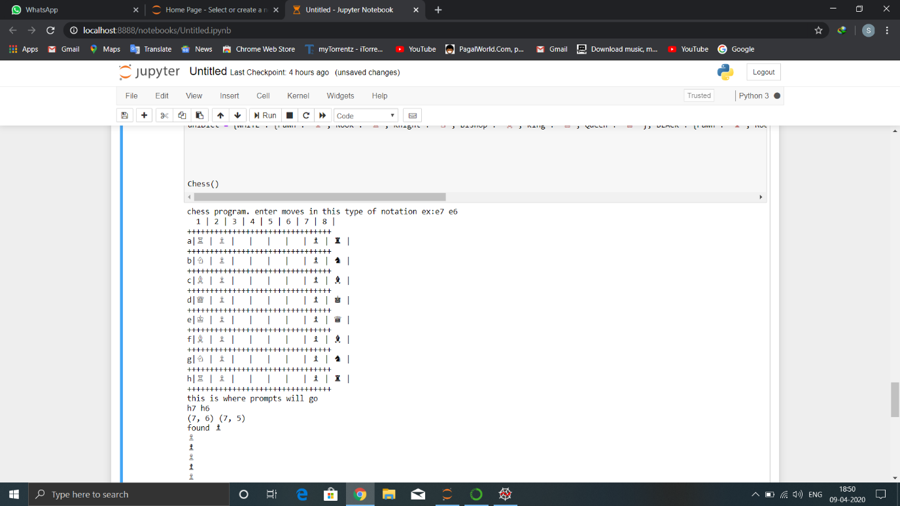

Here we make a move in algebraic notation like h7 h6 i.e.(h7 place piece will go to h6)

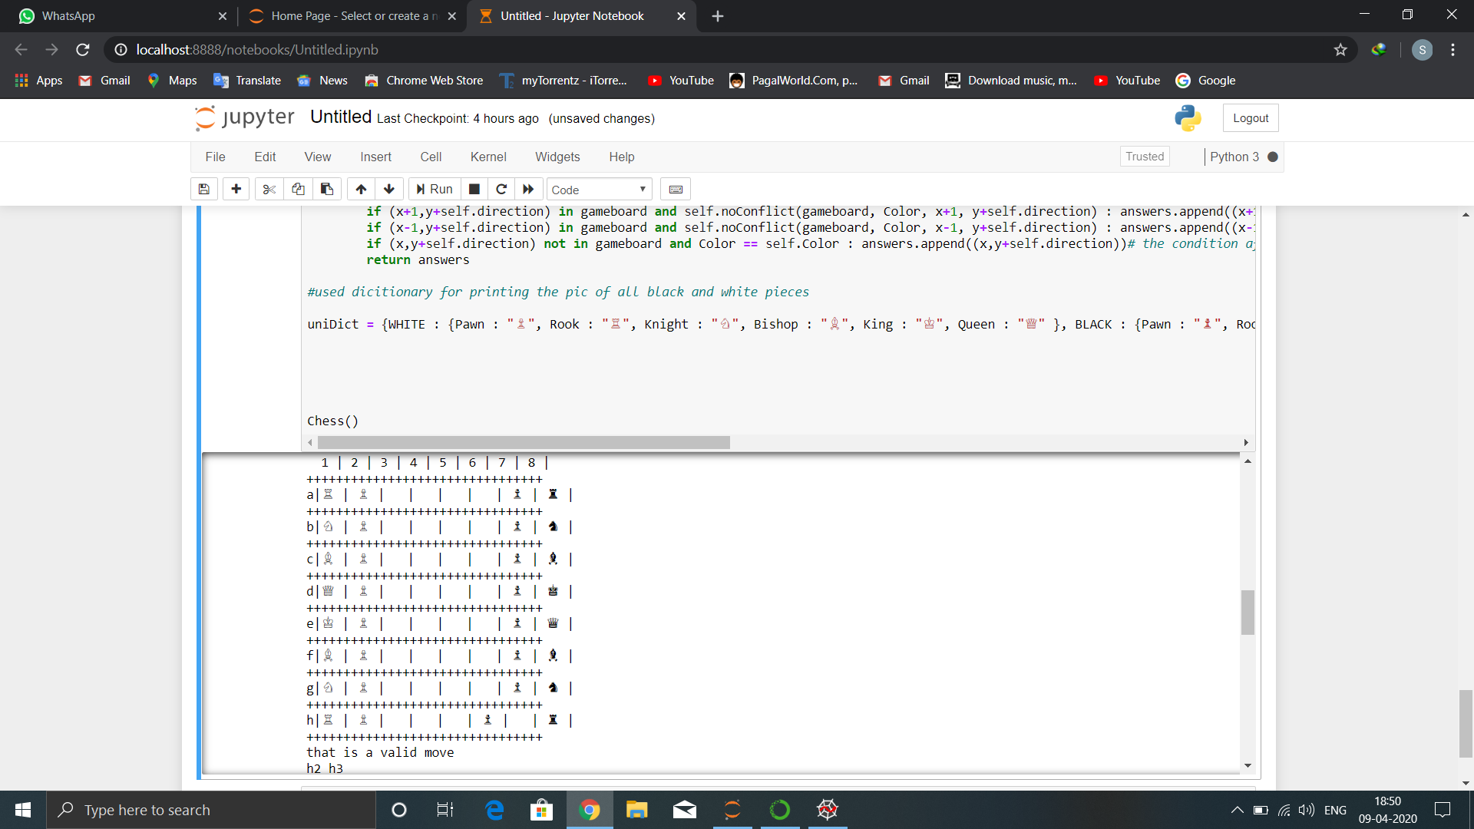

Here we made the opponent move i.e.h2 h3

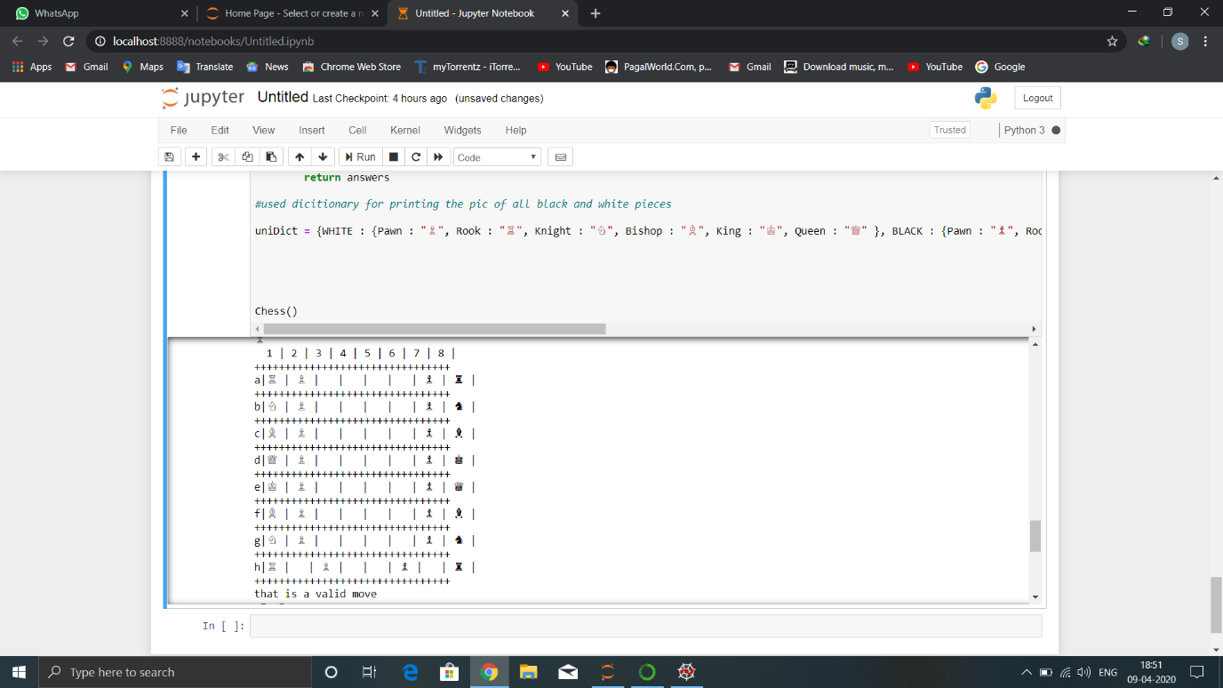

Here we call a wrong move so it shows invalid move.

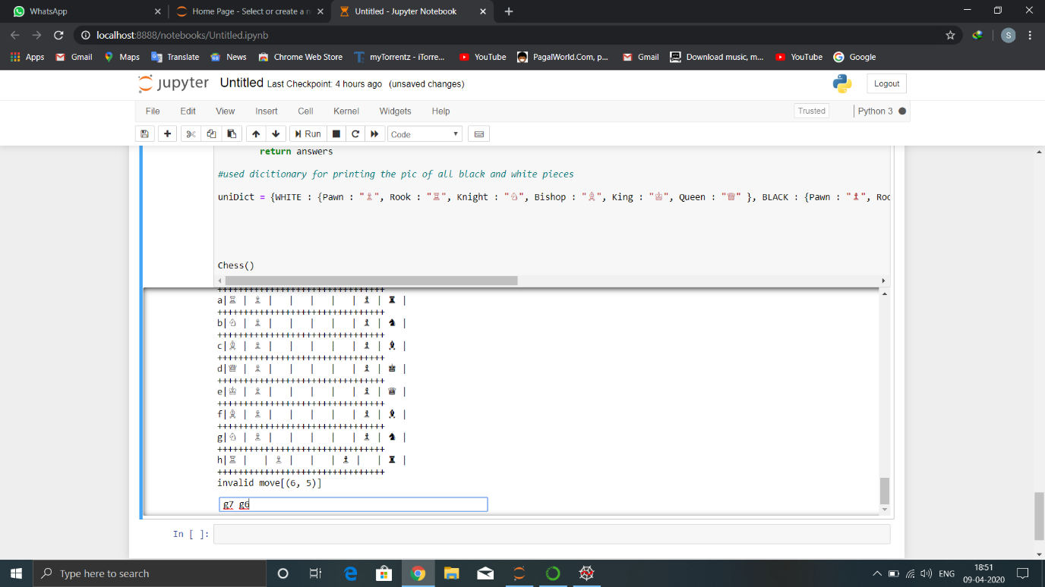

Here we move g7 g6:

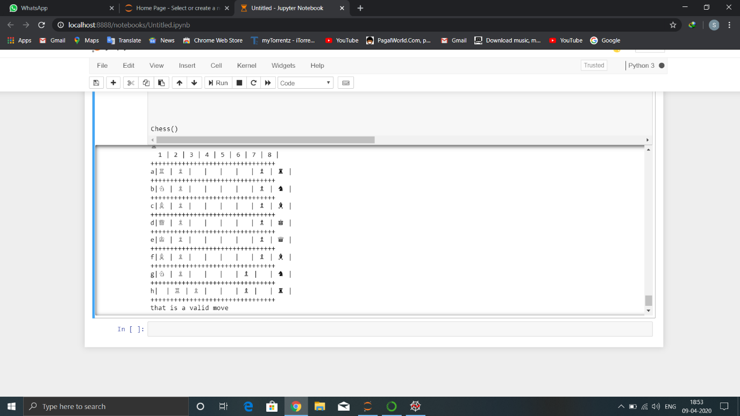

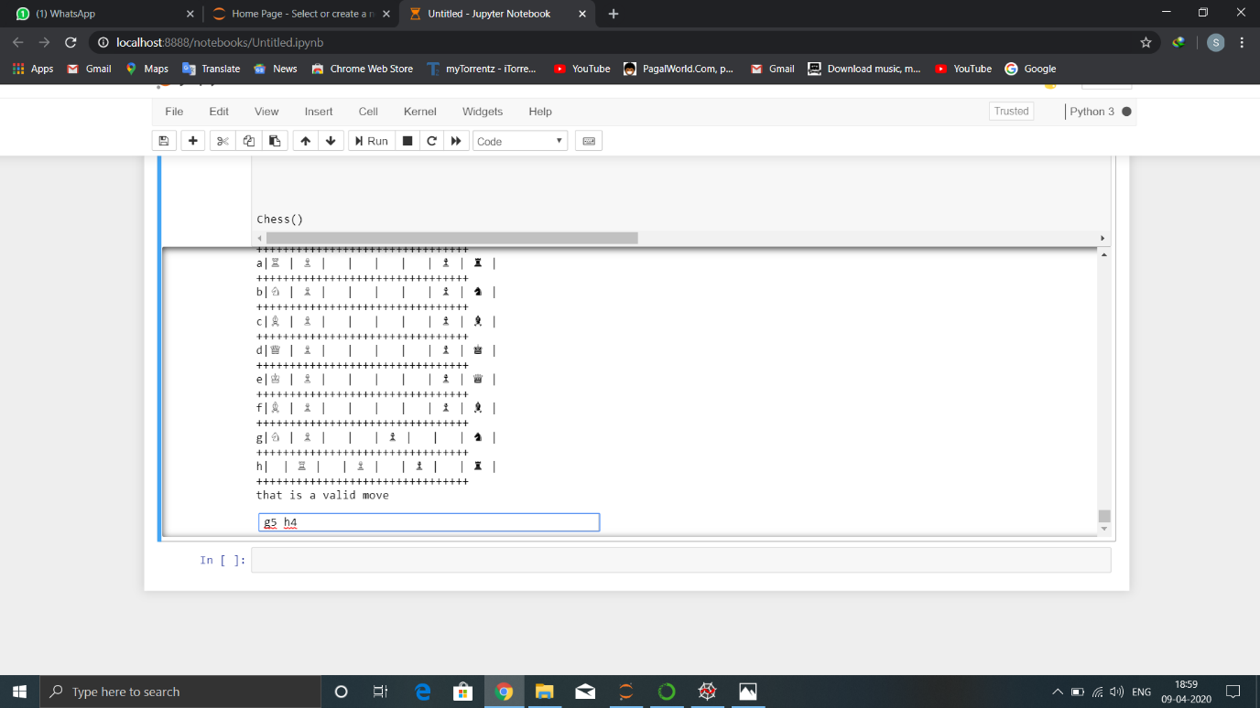

In this we make a move to eliminate one of white piece:

